SONG JOURNEY
"All Along the Watchtower"
Bob Dylan · made famous by Jimi Hendrix
Thread song — it appears across all 5 modules
One song, five layers. Each module adds a new skill to this song. Layer 6 is a bonus — a three-part Hendrix-style lead.
Form One loop, repeating under every verse and every solo
The loop Am · G · F · G
Who plays it Dylan sings over it; Hendrix solos over it
Rhythm Teaching layers: 2 beats per chord. No capo.
Tempo Practice at 60 BPM. Play-along track: 115 BPM.
LAYER 1 Listen Module 1
This song exists twice: Dylan's original and Hendrix's cover. Same three chords, very different guitars.
1. Listen for which guitar is acoustic and which is electric.
2. Listen for how each version feels.
3. Listen for the Am · G · F · G loop repeating underneath.
Do it: Listen to the opening minute of both versions.
Decide which guitar is acoustic and which is electric.
Name one word for how each version feels.
You've got it when: You can hum the main hook from memory.
Level up
Listen once more. Find where the main solo changes from melody, to slide, to wah pedal.
LAYER 2 Bass Line Module 2
Three notes on the low E string carry this whole song: the roots of the Am · G · F · G loop. This riff was your Module 2 assessment piece.
Bass loop · low E string · one lap = two bars
A A G G F F G G (loop)
e |--------------------|--------------------|
B |--------------------|--------------------|
G |--------------------|--------------------|
D |--------------------|--------------------|
A |--------------------|--------------------|
E |--5----5----3----3--|--1----1----3----3--|

Play it: Pick one note per beat at 60 BPM. Each root twice before it changes.
Run 4 laps without stopping.
Index on fret 1 (F). Ring on fret 3 (G). Pinky on fret 5 (A).
You've got it when: You can play it from memory at 60 BPM, no stops.
Level up
Pick each root twice per beat instead of once. Same frets, same order.
Level up · same notes, twice the speed · one lap = one bar
A A G G F F G G (loop)
e |------------------|------------------|
B |------------------|------------------|
G |------------------|------------------|
D |------------------|------------------|
A |------------------|------------------|
E |-5-5-5-5-3-3-3-3--|-1-1-1-1-3-3-3-3--|

LAYER 3 Power Chords Module 3
Same three roots you played in Layer 2 — each note now also plays the note a fifth above it. One two-string shape sliding along the low E string.
Power chords · root on low E, 5th on A · one lap = two bars
A5 A5 G5 G5 F5 F5 G5 G5 (loop)
e |--------------------|--------------------|
B |--------------------|--------------------|
G |--------------------|--------------------|
D |--------------------|--------------------|
A |--7----7----5----5--|--3----3----5----5--|
E |--5----5----3----3--|--1----1----3----3--|

Play it: Strum once per beat at 60 BPM. Each chord twice before it changes.
Run 4 clean laps. Land every change on the beat.
Keep your grip — one shape, your arm does the moving.
You've got it when: The loop runs at 60 BPM, every string ringing clean, no stops.
Level up
Change chords every beat instead of every 2 — same 60 BPM, twice the changes.
Level up · power chords, one per beat · 60 BPM
| A5 G5 | F5 G5 | (loop)
1 2 3 4 1 2 3 4

LAYER 4 Pentatonic Solo Module 4
The loop is in A minor, so A minor pentatonic Pattern 1 fits every bar — this is the fret shape Hendrix used for most of his solos. Start with three notes and leave gaps of silence between them.
Three rungs. Climb them in order.
Rung 1 · Rule of 3 — start here
Three starting notes · A minor pentatonic Pattern 1 · 5th position
E G A
e |----------------------------------|
B |----------------------------------|
G |----------------------------------|
D |--------------5---------7---------|
A |--7-------------------------------|
E |----------------------------------|

Play it: Loop the chords (play along, or with a partner on Layer 3).
Improvise 4 bars on the 3 notes, then 4 more adding 1 note from Pattern 1.
Start or end every phrase on A — the home note.
Rung 2 · The whole box
Ready for more than 3 notes? This is the whole box — A minor pentatonic Pattern 1 at the 5th fret. Run it up and back down, then improvise using any note in it. Every note fits all 3 chords — keep landing on A.
The whole box · A minor pentatonic Pattern 1 · 5th position
e |--5----------8--------------------|
B |--5----------8--------------------|
G |--5-------7-----------------------|
D |--5-------7-----------------------|
A |--5-------7-----------------------|
E |--5----------8--------------------|

Rung 3 · Two Hendrix-style licks
Two licks (short solo phrases) from the same box to start your solos. Learn them exactly, then change them: change one note, change the rhythm, make them your own.
Lick 1 · down and back up · quarter notes, lands on A
C A G A
e |--8----5---------5--|
B |------------8-------|
G |--------------------|
D |--------------------|
A |--------------------|
E |--------------------|

Lick 2 · the slide-in · lands on A
G/A C A
e |--------------------|
B |--------------------|
G |------------5-------|
D |--5/7------------7--|
A |--------------------|
E |--------------------|

You've got it when: You've climbed all three rungs — licks show up in your solos.
Level up
Start a phrase during the F bar and resolve it on the Am bar — real tension and release.
Level up · tension and release · 2 bars
C G C G C E A
e |--------------------|--------------------|
B |--------------------|--------------------|
G |--5-------5-------|--5-----------------|
D |------5-------5--|------------7-------|
A |--------------------|-------7------------|
E |--------------------|--------------------|

LAYER 5 Open Chords Module 5
The simple singalong version — closest to how Dylan actually plays it. The same loop becomes full open chords you strum and sing over.
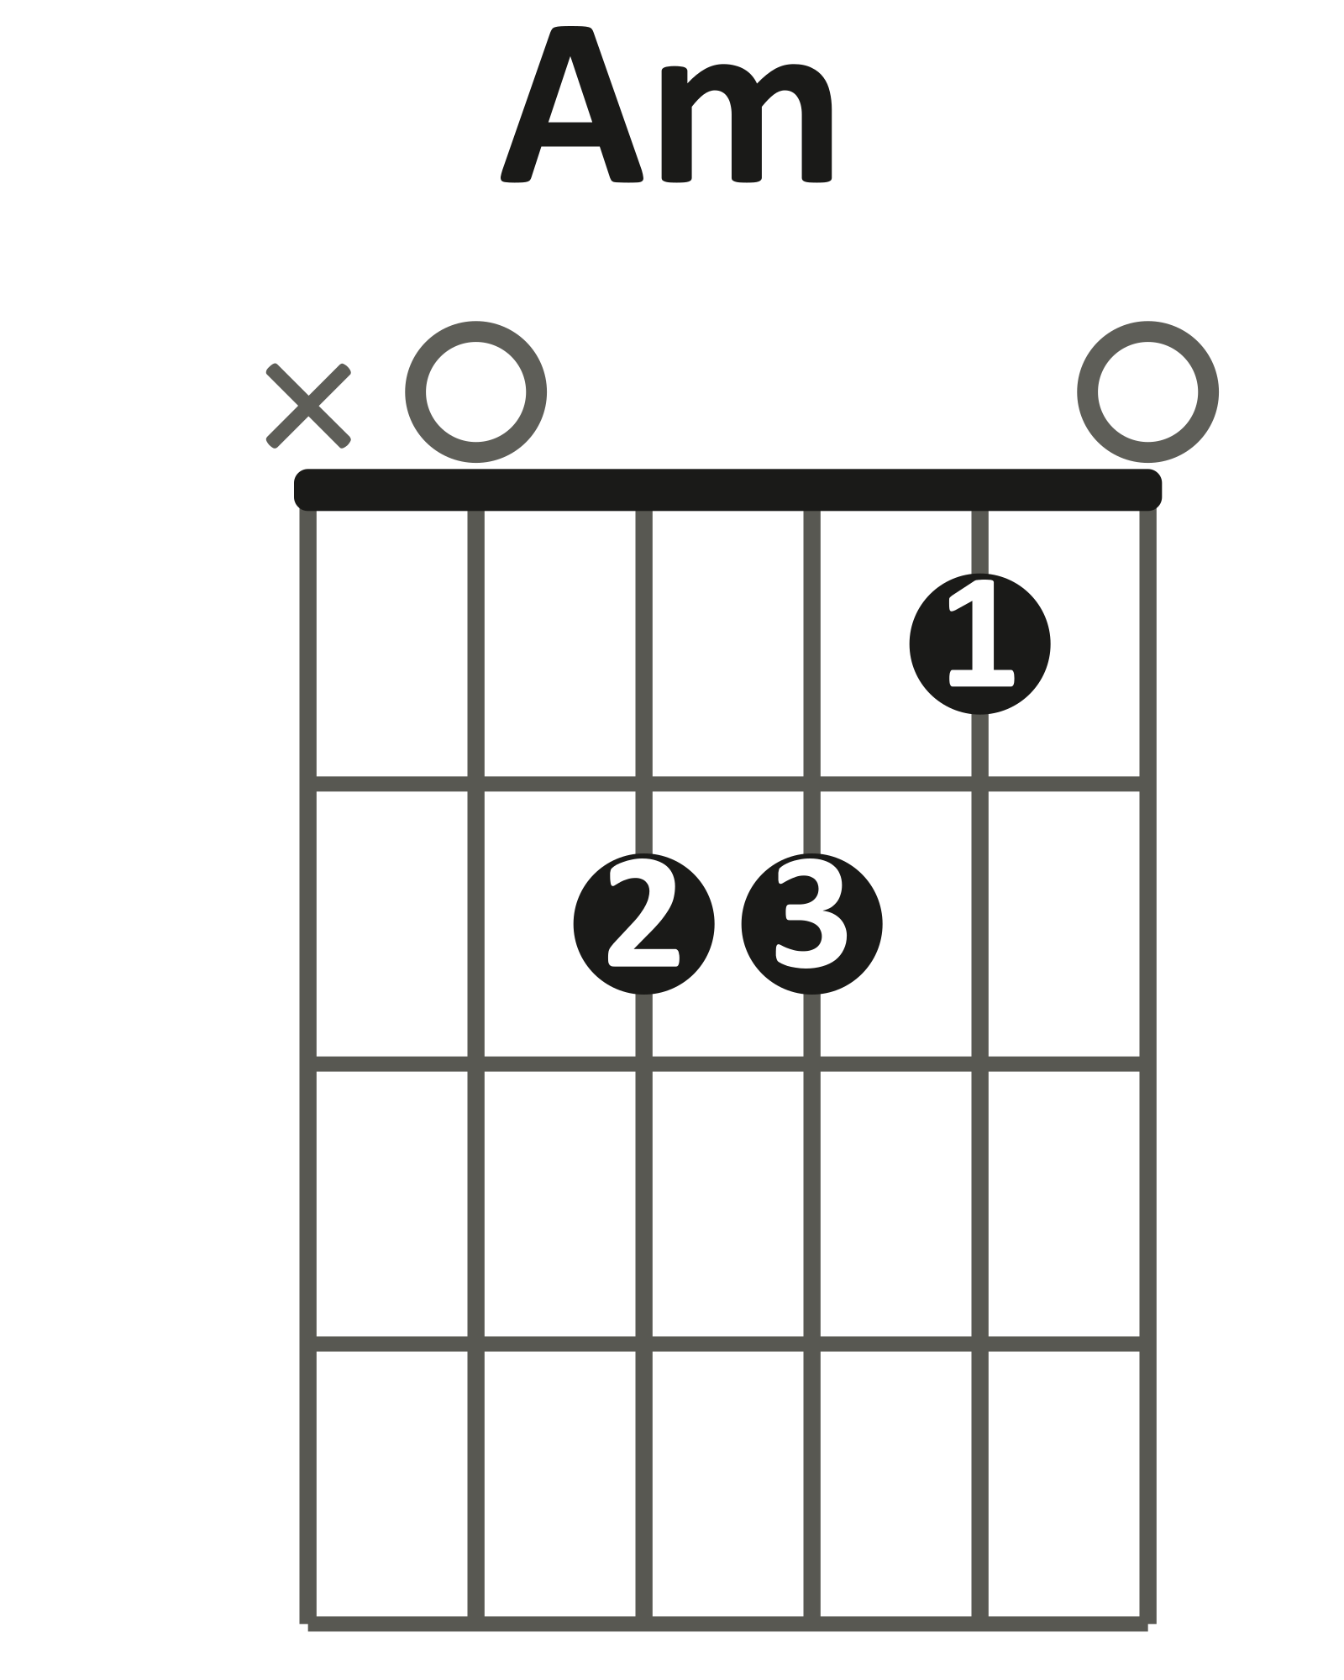 | 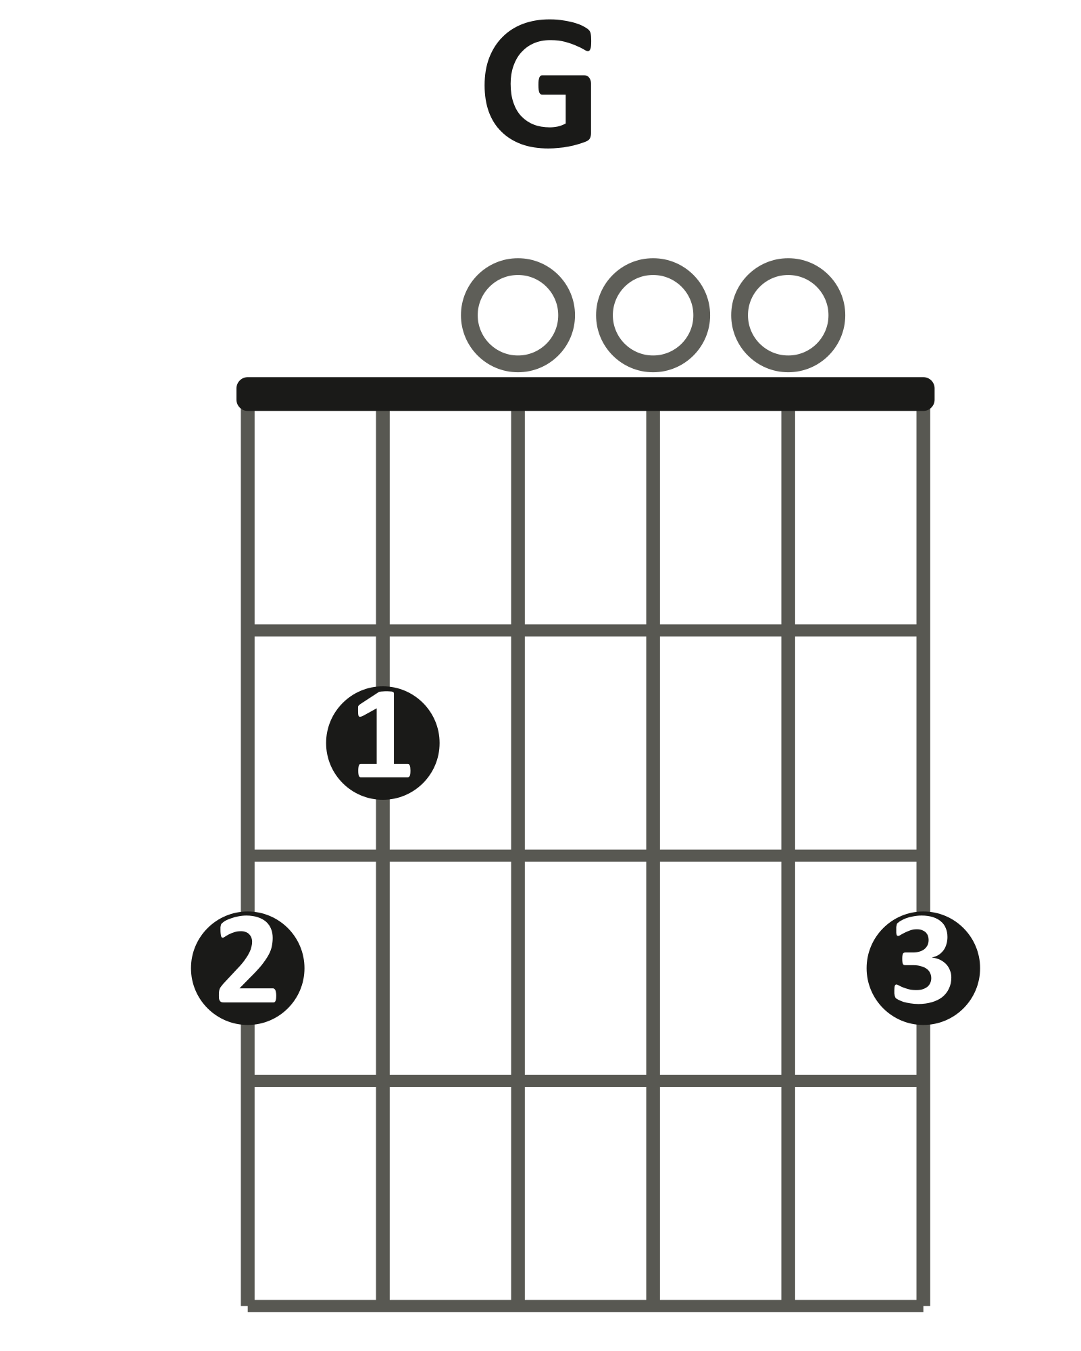 | 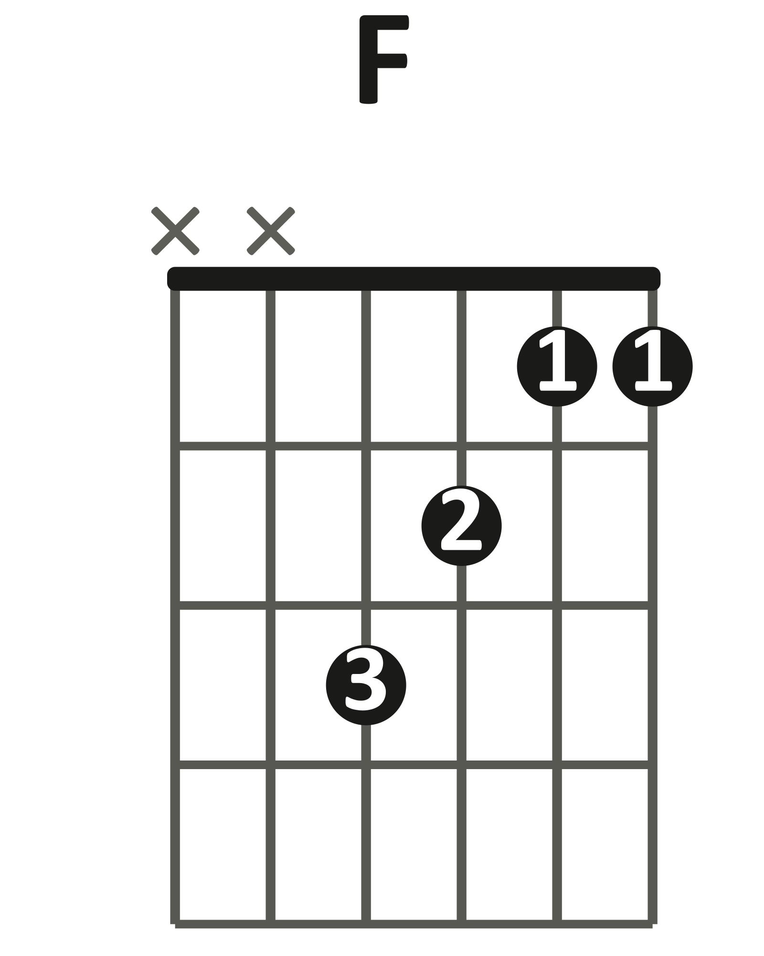  little shape (xx3211)

Singalong loop · 2 beats per chord · 60 BPM
| Am G | F G | (loop)
1 2 3 4 1 2 3 4

Play it: Down-strum, 2 beats per chord, 4 loops.
Listen for it — this is the same song you played in Modules 2 and 3, finally sounding full.
You've got it when: The full loop runs at 60 BPM with every change on the beat.
Level up
Trade loops with a partner playing Layer 3 power chords — Dylan and Hendrix at the same time. Use the Layer 3 chart above.
LAYER 6 Hendrix Lead Bonus
Optional harder challenge, no score. Best once Layer 4's pentatonic box feels automatic.
Hendrix never just strums this song — his guitar answers the vocal with short fills (a fill is a short extra run between main parts). Three parts below, all from the Pattern 1 box you learned in Layer 4.
Rung 1 · Part A — the verse answer
Part A · the verse answer · one note per beat · 60 BPM
Am G F G
A C A G C G A
e |--------------------|--------------------|
B |--------------------|--------------------|
G |-------5------------|--5-----------------|
D |--7---------7----5--|-------5----7-------|
A |--------------------|--------------------|
E |--------------------|--------------------|

Play it: One note per beat at 60 BPM, hand in 5th position — index fret 5, ring fret 7.
Bar 1 asks: A, C, A, G. Bar 2 answers: C, G, and lands on A — let it ring 2 beats.
Rung 2 · Part B — the entrance
Part B · the entrance · slide into A
Am G F G
G/A C D C A
e |--------------------|--------------------|
B |--------------------|--------------------|
G |------------5----7--|--5-----------------|
D |--5/7---------------|-------7------------|
A |--------------------|--------------------|
E |--------------------|--------------------|

Play it: Slide up the D string, fret 5 into fret 7 — pick once, glide, land on A.
Let it ring 2 beats, then answer: C, D, C, home to A.
Rung 3 · Part C — the climb and the fall
Part C · the climb and the fall · quarter notes
Am G F G
A C D E C A G A
e |--------------------|--8----5---------5--|
B |-----------------5--|------------8-------|
G |-------5----7-------|--------------------|
D |--7-----------------|--------------------|
A |--------------------|--------------------|
E |--------------------|--------------------|

Play it: Bar 1 climbs the box a note at a time: A, C, D, E.
Bar 2 leaps to the peak and falls home: high C, A, G, land on A.
Level up
Play it the way Hendrix does: strum a lap, add Part A, strum again, open the next lap with Part B, and save Part C for the ending.
FULL CHORD CHART
"All Along the Watchtower"
Bob Dylan · made famous by Jimi Hendrix
Key A minor
Tempo 115 BPM (Neil Young play-along) · 4/4
Rhythm Two beats per chord — one lap = two bars
Form Intro → Verse 1 → First solo → Verse 2 → Main solo → Verse 3 + outro — all over the same loop
Shapes you need
Am | G | F

THE LOOP
| Am G | F G |
The whole song is this one loop. Two beats on each chord; strum on 1 and 3, or on every beat.
INTRO
(loop, repeat)
Full band, full volume.
VERSE 1
(loop, repeat)
Vocal over the loop; lead guitar answers between lines.
FIRST SOLO
(loop, repeat)
Short solo from the pentatonic box (Layer 4).
VERSE 2
(loop, repeat)
Louder, fuller strumming.
MAIN SOLO
(loop, repeat)
Melody, then slide, then wah.
VERSE 3 + OUTRO
(loop, repeat)
The title line arrives here; the final solo fades out.
Teaching chart — simplified to match the Journey layers, not a note-for-note transcription. Chord names are what the class plays in standard tuning.

